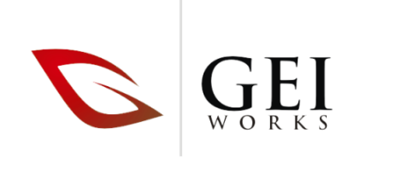
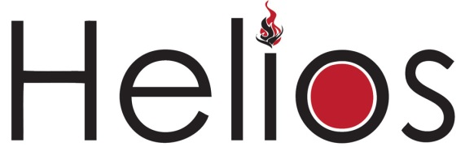

Solid Waste Application
Questionnaire

- Contact information: Contact name: NAME
Company/firm: COMPANY
Address: ADDRESS
Telephone: PHONE NUMBER.
Fax: FAX NUMBER
Email: EMAIL ADDRESS

2. Relationship of inquirer to the project: Choose inquirer’s relationship to project:
3. Experience of inquirer with Incineration Equipment: Choose experience level:
4. Type of project: Choose a project type:
5. Location of project: If outside of the USA, please advise nearest port of entry – click to type here
6. Composition of the waste stream: Be as specific as possible - Click to type here
7. BTU value of waste being incinerated if known? Click here to enter text.
8. Volume of waste: Enter number Choose a value:
9. Desired frequency and duration of operation: Enter duration of operation: Choose duration of use:
Enter frequency of operation: Choose Frequency:
10. Specific emissions requirements: Click here to enter text.
11. Available fuel: Diesel: ☐ Natural Gas ☐ LPG: ☐
12. Available electrical service:
Voltage: Click here to enter Frequency: 50 Hz ☐ 60 Hz ☐ Phase: One-Phase ☐ Three-Phase ☐ PHASE: Choose
13. Status of project: Choose an item.
14. Time frame for acquisition of equipment for project: Choose timeframe:
15. Scope of supply sought: Choose scope:

16. Additional comments:
Click here to enter text.

GEI Works LLC | www.geiworks.com | 772-646-0597 | 5400 85th Street, Vero Beach, FL 32967 | info@geiworks.com

